**PROJECT REPORT**

**ON**

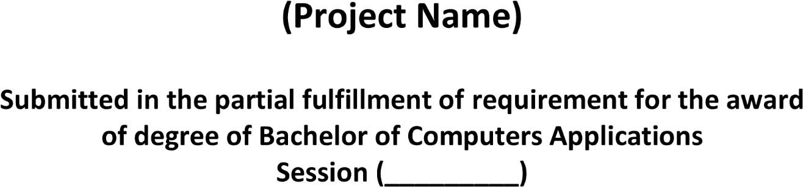

**2020-2023**

**Forms World**

**2020 - 2023**

***Ms. Parull Bhardwaj***

***Project In-charge***

***Shubham Dahiya***

***20012041042***

